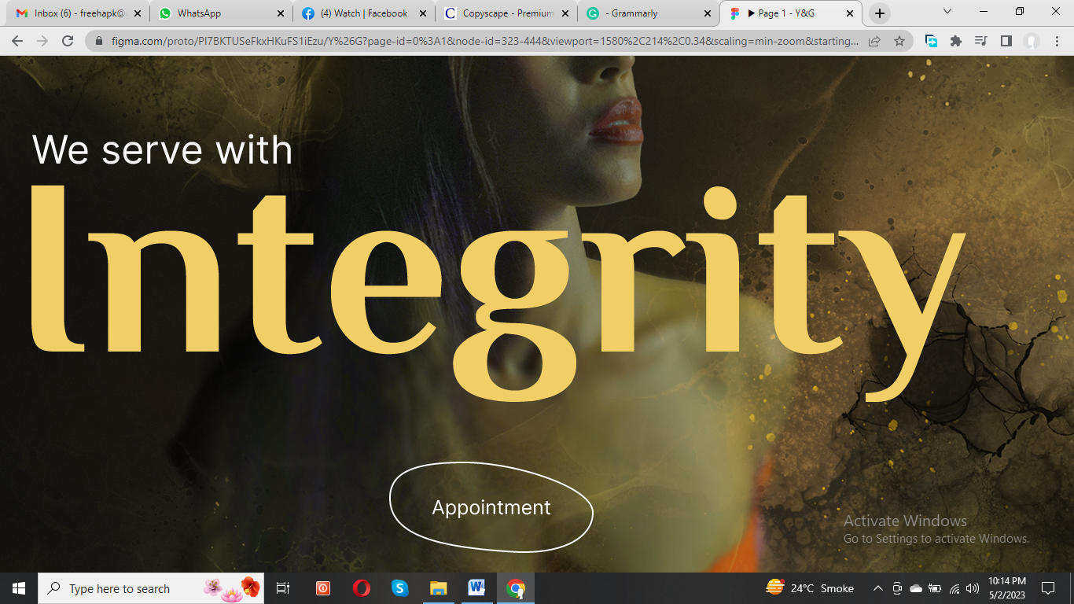

**(Text for banners)**

1. Transform Your Look with Confidence!
2. Y&G Salon

Where Style Meets Perfection

1. Step into Our World of Glamour!

Beauty is our passion, let us inspire you. 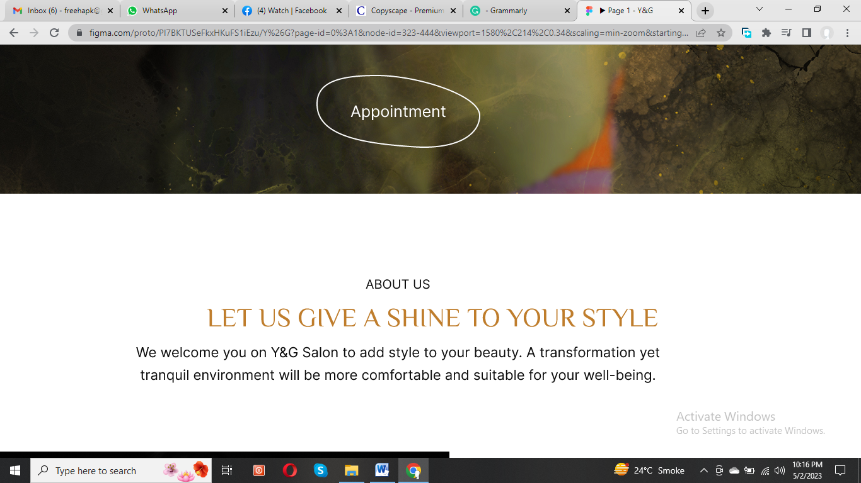

**Beauty is our passion, let us inspire you!**

We welcome you on Y&G Salon to add style to your beauty. A transformation yet tranquil environment will be more comfortable and suitable for your well-being.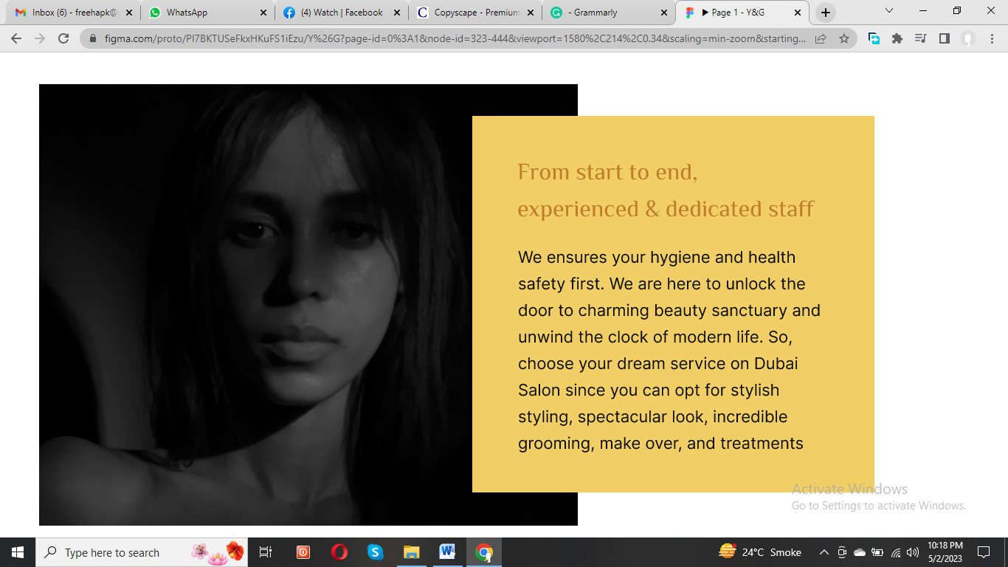

**Experience the Ultimate Transformation at Y&G Salon**

Experienced and dedicated staff will ensure your hygiene is top priorities from start to finish. Our **beauty salon Dubai** is a sanctuary where you can escape the stresses of modern life. Trust us to give your style the shine it deserves. We are here for **Home Services Salon Dubai.**

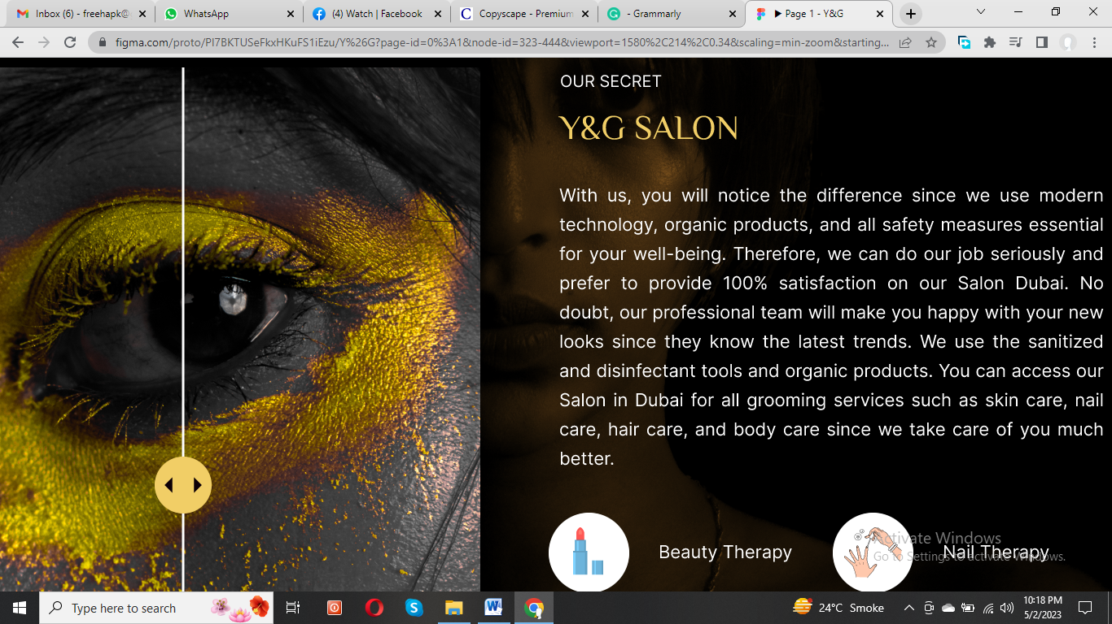

**Y&G Salon**

**Your Glam Hub**

Looking for the **nearest beauty salon to me**? Our **salon in UAE** prioritizes your well-being using modern technology, organic products, and all essential safety measures. Our commitment to providing top-quality service at **beauty salon in Dubai** ensures that we take our job seriously and strive for 100% satisfaction. Our secret for **salon at-home services** is that we use sanitized and disinfected tools and organic products to ensure that your experience is enjoyable and safe. Get a wide range of services from skincare to nail care, hair care to body care, as well as bridal makeup in Dubai. Come visit our **salon in Dubai** today!

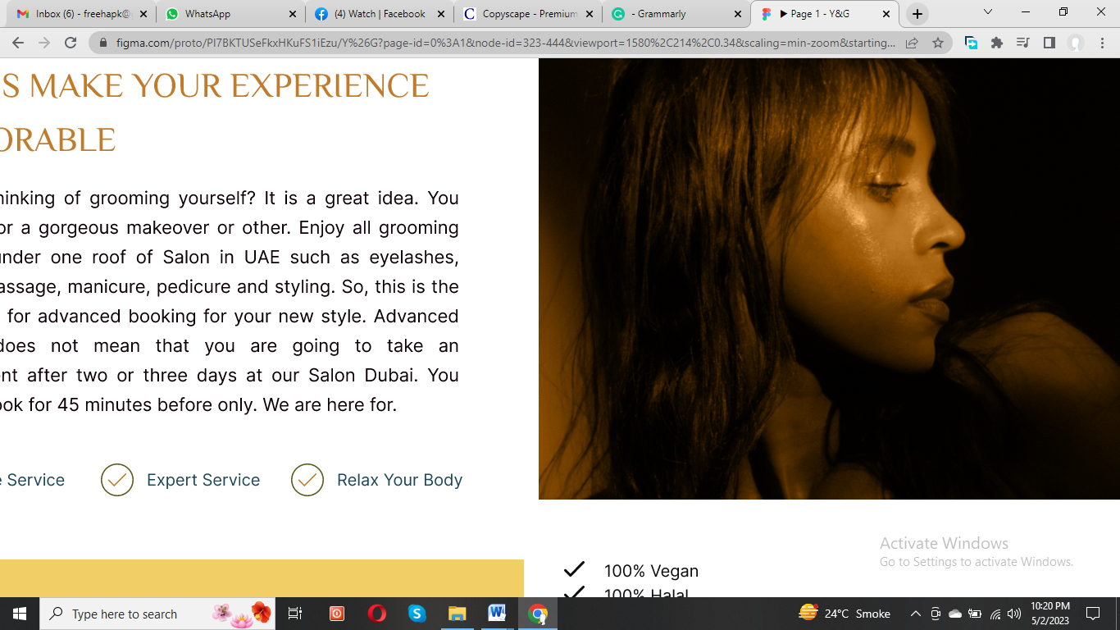

**Relax and unwind while we work our magic!**

Welcome to Our UAE Salon!

Are you looking to treat yourself to some much-needed grooming? Look no further than our **salon in UAE**! We offer a wide range of services under one roof. Don't wait to schedule your appointment for a stunning new look and join our **salon services at home Dubai**. Our advanced booking system allows you to reserve your spot just 45 minutes ahead. No need to wait days or even weeks for the appointment at our **beauty salon Dubai**. Discover the ultimate luxury and pampering since we are here for

* Professionalism
* 100% Privacy
* Serene Ambience Zone

Discover Our Natural and Organic Beauty Products here

* Botanical extracts
* Plant-derived glycerin
* Plant-derived essential oils
* Organic olive oil
* Organic sea salt
* HICC-free(Allergen-free) Fragrance
* 100% Halal
* 100% Vegan

**Loyalty Cards & prepaid Membership Cards are available!**

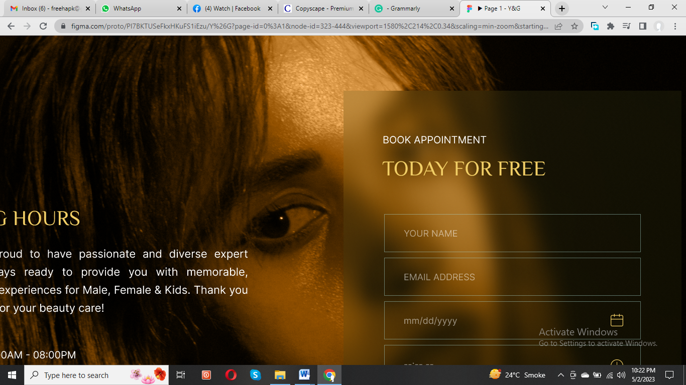

**Y&G SALON FOR MALE & FEMALE**

**Schedule an Appointment**

At Y&G **Salon in UAE**, we are open Monday to Friday from 8:00 am to 8:00 pm, and on Saturdays and Sundays from 10:00 am to 10:00 pm. Join us on flexible working hours during your lunch break or a relaxing spa session on the weekend or **salon services at home Dubai**.